**Lab Practical #01:**

Study of basic networking commands and IP configuration.

**Practical Assignment #01:**

1. Perform and explain various networking commands listed below:
   1. ipconfig
   2. ping
   3. getmac
   4. systeminfo
   5. traceroute / tracert
   6. netstat
   7. nslookup
   8. hostname
   9. pathping
   10. arp

## ipconfig

### Description:

The default is to display only the IP address, subnet mask and default gateway for each adapter bound to TCP/IP.

|  |  |  |
| --- | --- | --- |
| No. | Option | Description |
| 1 | showclassid | Displays all the dhcp class IDs allowed for adapter. |
| 2 | all | Display full configuration information. |
| 3 | relese | Release the IPv4 address for the specified adapter. |
| 4 | renew | Renew the IPv4 address for the specified adapter. |
| 5 | displaydns | Display the contents of the DNS Resolver Cache. |

### Implementation:

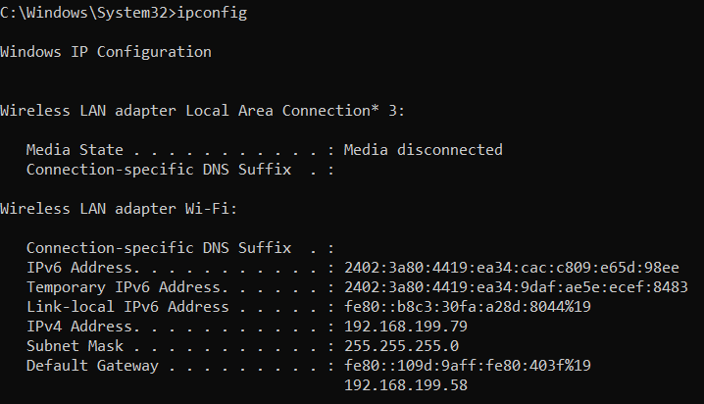

## 1. Showclassid :-

## 2. All:-

## 3. Relese:-

## 4. Renew :-

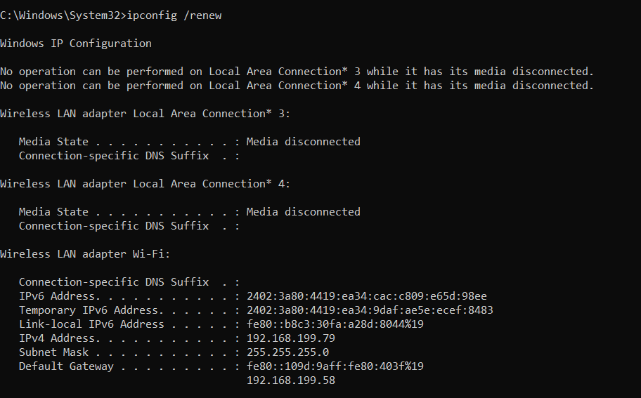

## 5. Displaydns :-

## Ping :-

### Description:

ping is the primary TCP/IP command used to troubleshoot connectivity, reachability, and name resolution.

|  |  |  |
| --- | --- | --- |
| No. | Option | Description |
| 1 | -a | Resolve addresses to hostnames. |
| 2 | -t | Ping the specified host until stopped.  To see statistics and continue - type Control-Break; To stop - type Control-C. |
| 3 | -n | Number of echo requests to send. |
| 4 | -r | Record route for count hops (IPv4-only). |
| 5 | -w | Timeout in milliseconds to wait for each reply. |

### Implementation:

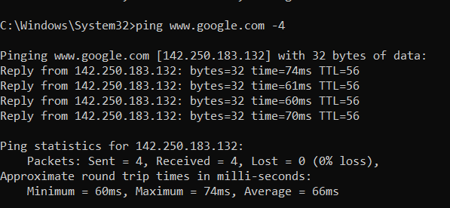

* **1. Ping -a :-**

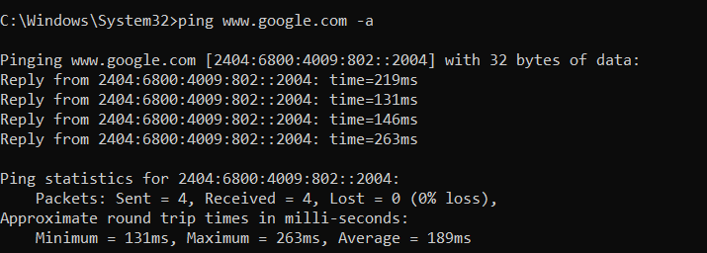

* **2. Ping -t :-**

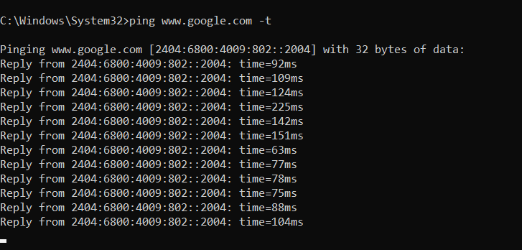

* **3. ping -r :-**

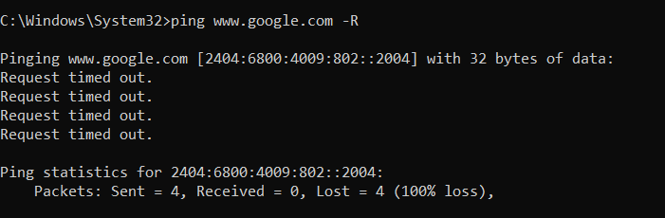

* 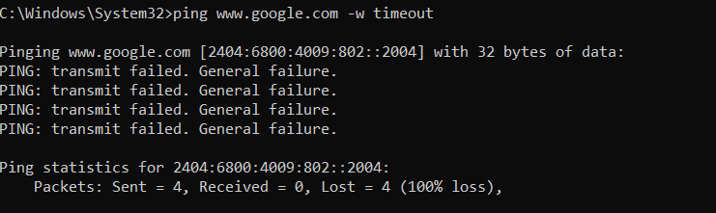**4. ping -w :-**
* **5. ping -n:-**

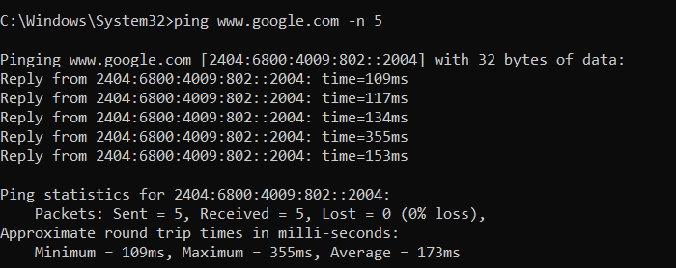

## Getmac :-

### Description:

This tool enables an administrator to display the MAC address for network adapters on a system.

|  |  |  |
| --- | --- | --- |
| No. | Option | Description |
| 1 | -v | Specifies that verbose output is displayed. |
| 2 | -nh | Specifies that the "Column Header" should  not be displayed in the output.  Valid only for TABLE and CSV formats. |
| 3 | -fo | Specifies the format in which the output  is to be displayed. |
| 4 | -fo table | Valid values: "TABLE" |
| 5 | -fo list | Valid values: "LIST" |

### Implementation:

* **1.Getmac -v :-**

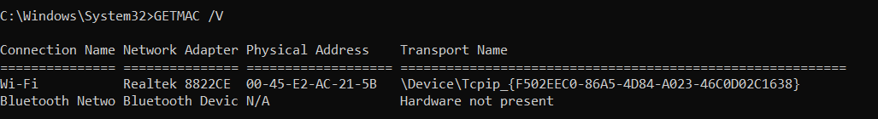

* **2.Getmac -nh :-**

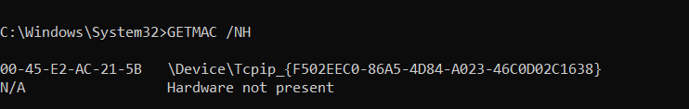

* **3.Getmac -fo :-**

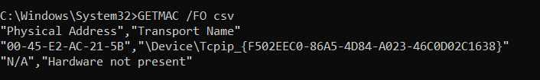

* **4.Getmac -fo table :-**

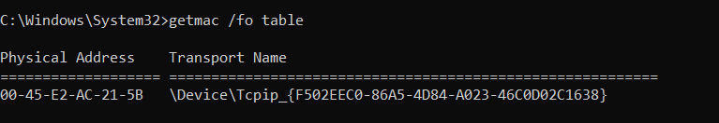

* 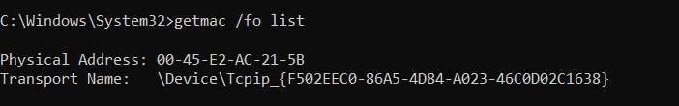**5. Getmac -fo list :-**

## Systeminfo :-

### Description:

This tool displays operating system configuration information for a local or remote machine, including service pack levels.

|  |  |  |
| --- | --- | --- |
| No. | Option | Description |
| 1 | sysboottime | This command will provide you with a detailed list of system details, including the “System Boot Time” that provides the information you need. |
| 2 | - s remotpc | Specifies the remote system to connect to. |
| 3 | Fo - list | Specifies the format in which the output  is to be displayed. Valids values: "LIST" |
| 4 | Fo - table | Valid values: "TABLE" |
| 5 | Fo - csv | Valid values: "CSV” |

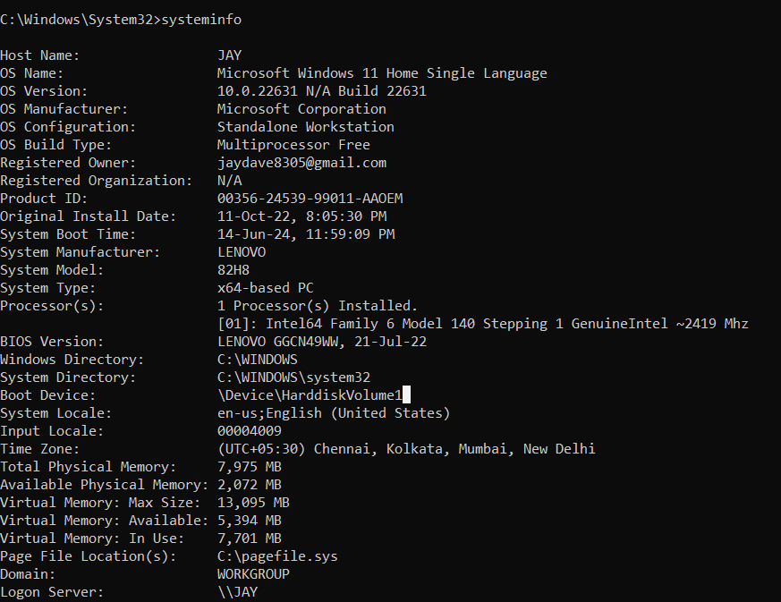**Implementation:**

* **1.sysboottime :-**

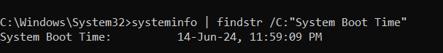

* 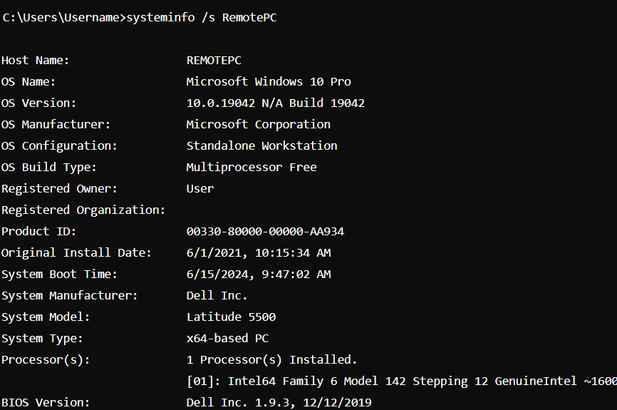**2. -s remotepc :-**
* **3.- /fo csv:-**

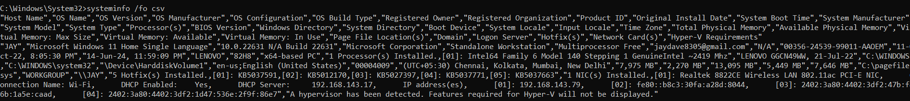

* **4. /fo list :-**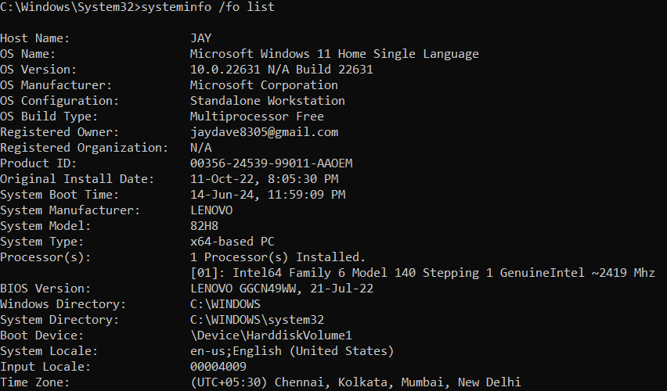
* **5. /fo table :-**

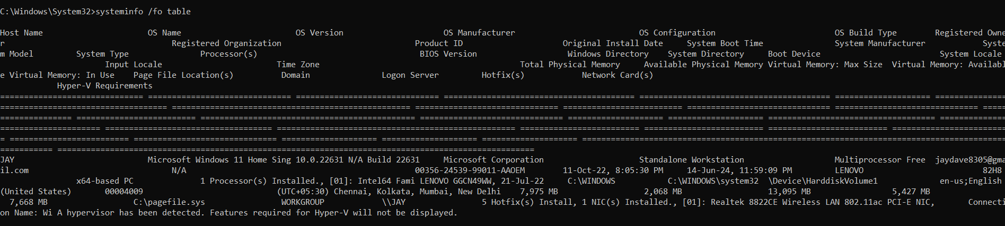

## Tracert :-

### Description:

TRACERT is useful for troubleshooting large networks where several paths can lead to the same point or where many intermediate components (routers or bridges) are involved.

|  |  |  |
| --- | --- | --- |
| No. | Option | Description |
| 1 | -r | Trace round-trip path (IPv6-only). |
| 2 | -h | Maximum number of hops to search for target. |
| 3 | -d | Do not resolve addresses to hostnames. |
| 4 | -6 | Force using IPv6. |
| 5 | -4 | Force using IPv4. |

**Implementation :-**

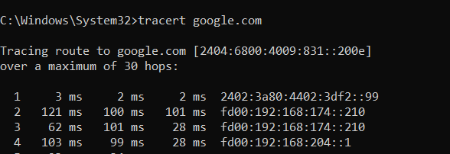

* **1. Tracert -r :-**

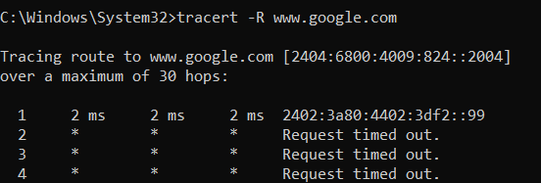

* **2. Tracert -h :-**

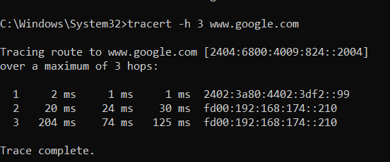

* **3. Tracert -d :-**

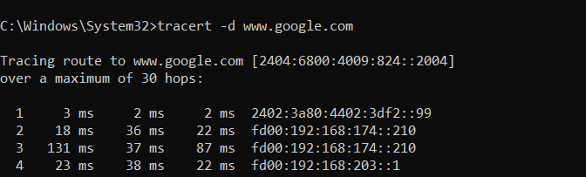

* **4. Tracert -6 :-**

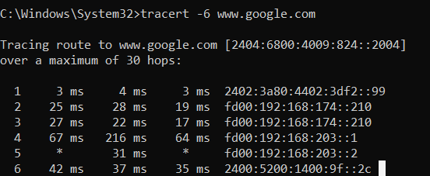

* 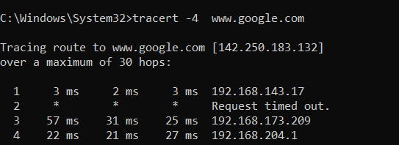**5. Tracert -4 :-**

## Netstat :-

### Description:

Displays protocol statistics and current TCP/IP network connections.

|  |  |  |
| --- | --- | --- |
| No. | Option | Description |
| 1 | -i | Displays the time spent by a TCP connection in its current state. |
| 2 | -f | Displays Fully Qualified Domain Names (FQDN) for foreign addresses. |
| 3 | -e | Displays Ethernet statistics. This may be combined with the -s option. |
| 4 | -b | Displays the executable involved in creating each connection or listening port. |
| 5 | -a | Displays all connections and listening ports. |

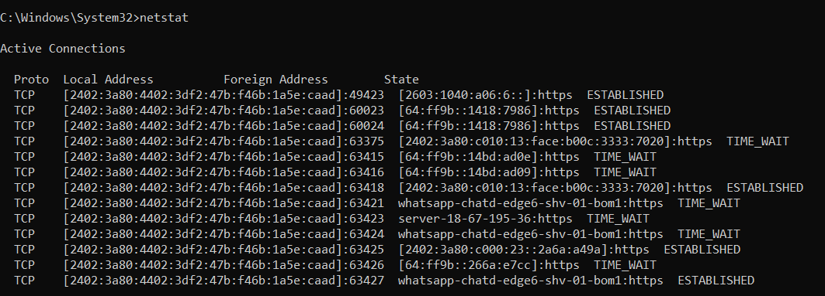**Implementation :-**

* **1. Netstat -I :-**

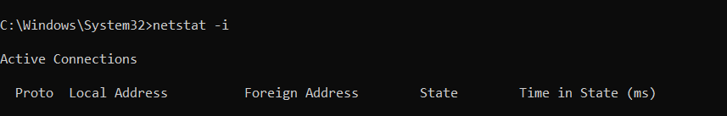

* 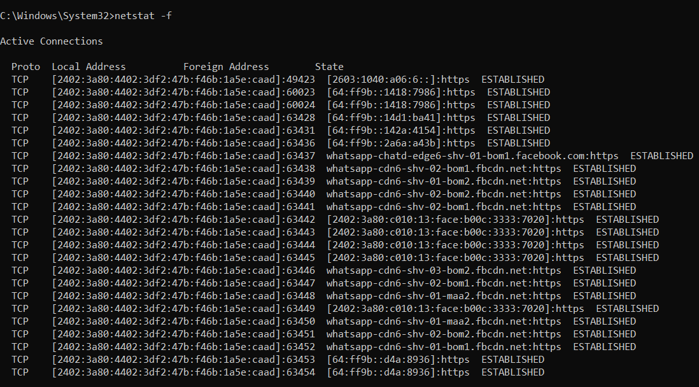**2.** **Netstat -f :-**
* **3.** **Netstat -e :-**

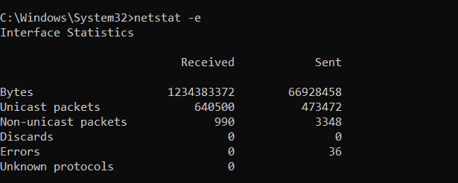

* 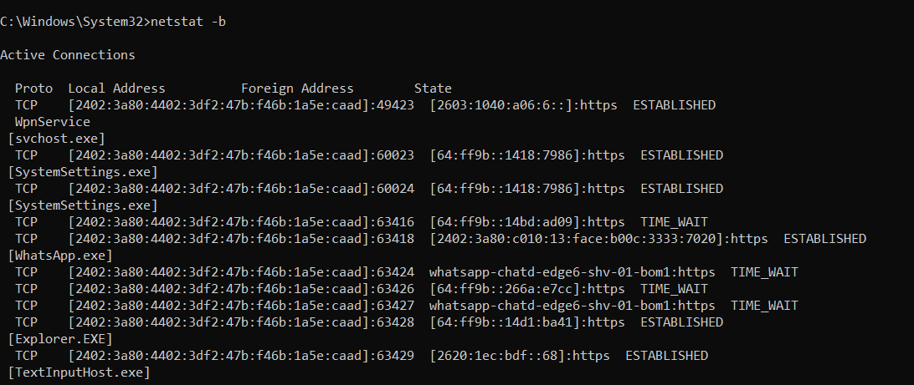**4.** **Netstat -b :-**
* **5.** **Netstat -a :-**

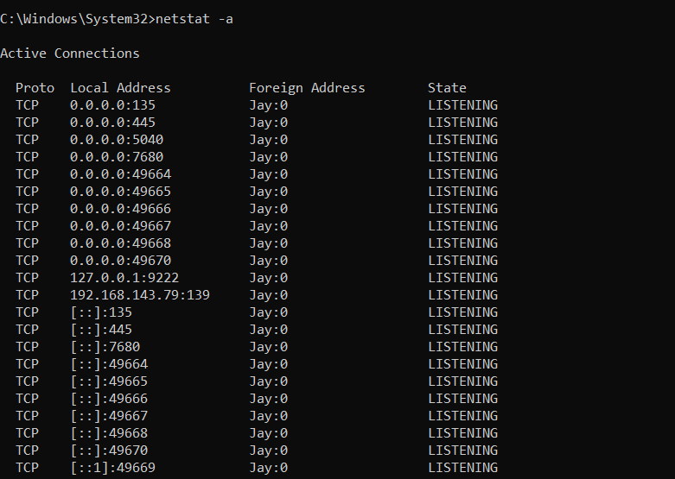

## Nslookup :-

### Description:

Nslookup is the name of a program that lets users enter a host name and find out the corresponding IP address or domain name system (DNS) record.

|  |  |  |
| --- | --- | --- |
| No. | Option | Description |
| 1 | - norecurse | Directs the NSLOOKUP command to request a recursive query when querying a name server. |
| 2 | -host | Provides detailed host information during the lookup. |
| 3 | -dns | Specifies the DNS server to use for the query. |
| 4 | -debug | Provides detailed debug information during the lookup. |
| 5 | -retry | Sets the number of retries to 3 if the DNS query times out. |

**Implementation :-**

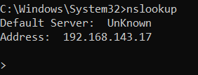

* **1.-no recurse :-**

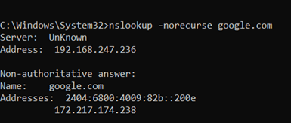

* **2.-host :-**

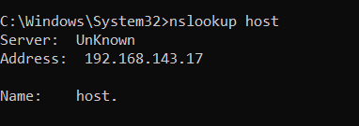

* **3. -dns :-**

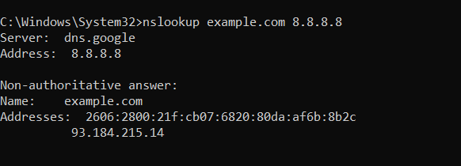

* **4.-debug :-**

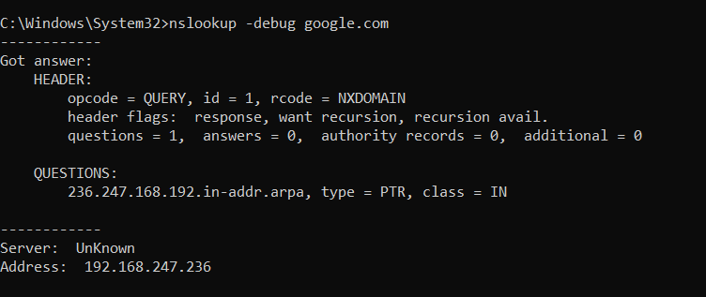

* **5.-retry:-**

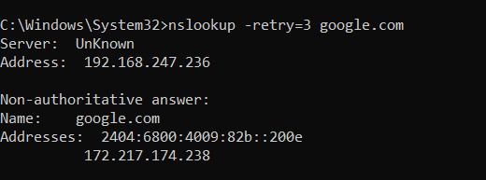

## Hostname :-

### Description:

Prints the name of the current host.

|  |  |  |
| --- | --- | --- |
| No. | Option | Description |
| 1 | -workgroup | This command displays the fully qualified domain name of system. |
| 2 | -printname | This Command display only the hostname . |
| 3 | -print | This command displays a message followed by the hostname. |
| 4 | -ip | This command displays the hostname and ipv4 address of the system. |
| 5 | -getwini | This command displays the domain name of system. |

**Implementation :-**



* **1. -workgroup :-**
* **2.-printname :-**

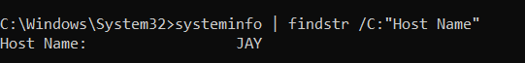

* **3.-print :-**



* **4.-ip :-**

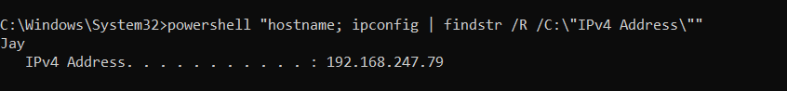

* 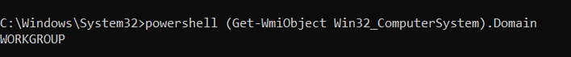**5.-getwini :-**

## Pathping :-

### Description:

 It is considered an alternative to tracert and it combines ping and tracert commands.

|  |  |  |
| --- | --- | --- |
| No. | Option | Description |
| 1 | -w | This command sets the timeout for each reply 500 milliseconds. |
| 2 | -n | Do not resolve addresses to hostnames. |
| 3 | -g | Loose source route along host-list. |
| 4 | -6 | Force using IPv6. |
| 5 | -4 | Force using IPv4. |

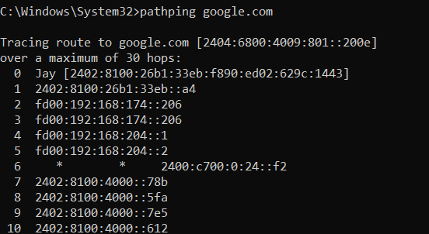**Implementation :-**

* **1. Pathping -w :-**

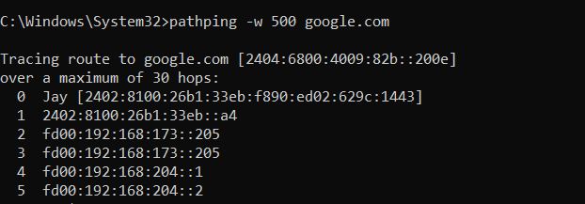

* 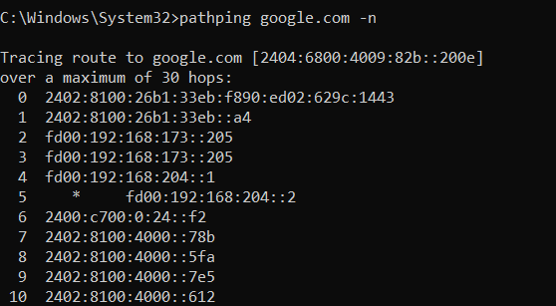**2. pathping -n :-**

* **3. pathping -g :-**

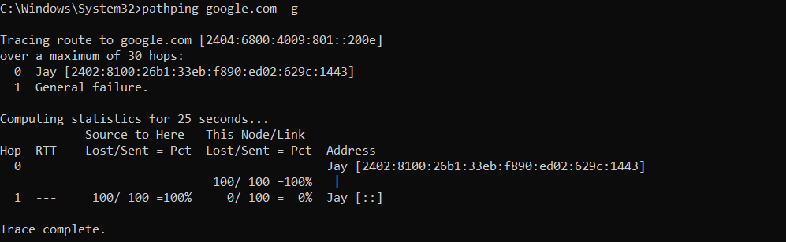

* **4. pathping -6 :-**

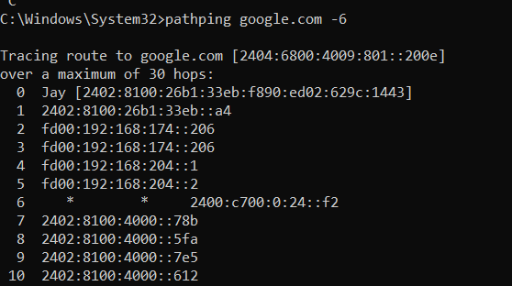

* **5. pathping -4 :-**

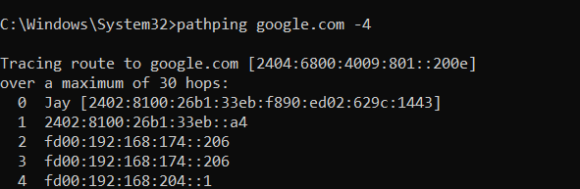

## 10 Arp :-

### Description:

 Displays and modifies the IP-to-Physical address translation tables used by address resolution protocol (ARP).

|  |  |  |
| --- | --- | --- |
| No. | Option | Description |
| 1 | -a | Displays current ARP entries by interrogating the current protocol data. |
| 2 | -v | Displays current ARP entries in verbose mode. |
| 3 | -s | Adds the host and associates the Internet address inet_addr with the Physical address eth_addr. |
| 4 | -g | Same as -a. |
| 5 | -find | This command filters the ARP table entries to only show those in subnet. |

**Implementation :-**

* **1. Arp -a :-**

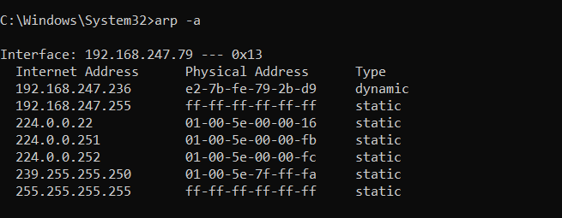

* **2. Arp -v :-**

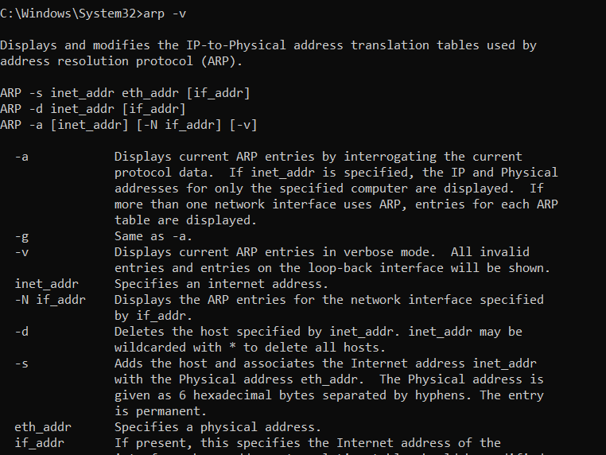

* 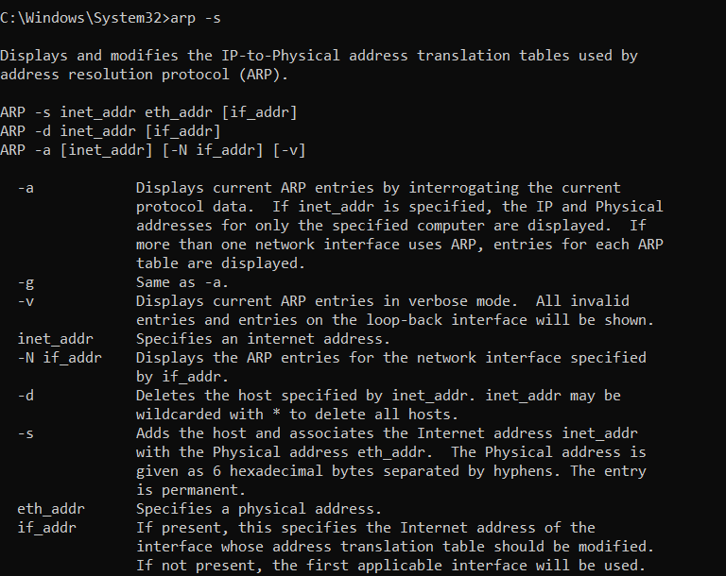**3. Arp -s :-**
* **4. Arp -g :-**

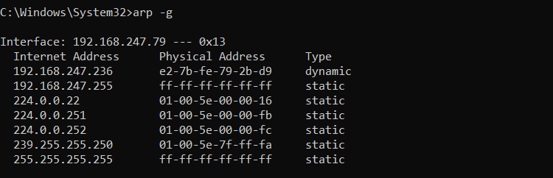

* **5. Arp -find :-**

